4.99 · 102 reviews
Cleanliness
5.0
Accuracy
5.0
Communication
5.0
Location
4.9
Check-in
5.0
Value
4.9

Veronica
- March 2023

Thanks for hosting us again for the Pepsi Challenge ski race, and for lending us snowshoes for the backyard tour! The homemade ice cream bar from your General Store was a nice treat after the race 😁

Brooklyn
- February 2023

The property was beautiful and the owners were so kind! I would highly recommend this place. I’m definitely going to come back to this one!!!

Maggie
- February 2023

Ericka and Jack were lovely hosts, it was a beautiful location and very private. Had everything we needed and more, definitely will be back in the future. :)

Sarah
- February 2023

Would recommend to anyone in a heartbeat: reasonable price, great location, quiet and beautiful atmosphere. Hosts are very friendly and helpful and go beyond in helping with anything that you need.

Gregory
- February 2023

although a little more expensive than local hotels, the location is incredibly private and the host was excellent. The in-floor heating kept us very comfortable during the coldest month. The amenities were top notch, with a gas range and a coffee maker, you could make anything you desire. The "general store" is adorable, little preserves and ice creams to purchase at reasonable prices. We went to Giants ridge for a day of skiing and it was a short drive away. The host even went so far as plugging my car in for me.

Deanna
- January 2023

This is one of the few Airbnbs I’ve stayed in that was truly more lovely than expected. The pictures don’t do the place justice. It’s a lovely setting and a cozy and calming space. The in-floor heat was awesome. We stayed here while xc skiing at Giants Ridge and it was close and easy to find. Bonus was picking up a dozen fresh eggs at the farm store when we left. Thank you!

Micaela
- November 2022

What a beautiful location out in the woods! We enjoyed our stay here.

Maximilian
- November 2022

This place is a wonderful escape to an idyllic farm getaway! Peaceful swaying, fields right out your door, with gorgeous evergreens and birch trees extending through the rest of the property. Garden houses! A cute little white farmhouse, adorable red barn with chickens that can’t wait to come greet you! A little store with amazing homemade canned goods. And two incredibly kind and wonderful hosts who are so welcoming and make this place feel like a home. Ericka and Jack do everything they can to make each of their guests stays enjoyable and unique! Whether it be showing you around the farm, helping you chop wood and build a fire, talking canning and cooking local, or just general warm, friendly conversation. I had such an incredible stay here, it was the perfect place to recharge outside of the cities in a place that felt like home. And, a great place to do some painting! I can’t wait to come back!

Randy
- October 2022

Nice quiet place to stay at.

Dale And Ruth
- October 2022

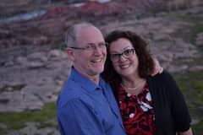

Ericka’s Studio is spotless and charming. The heated floors, fantastic bed, nicely prepped kitchen, books and games AND amazing views make this a great little getaway place even in chilly October. I can only imagine how much fun the property must be in the spring and summer. Terrific.
My elderly mom and I came to visit my very sick brother who lives nearby. The Studio was nearly perfect with the exception of a few things.
I loved the bed… mom could not get UP in it. The shower is very small and inaccessible for someone with mobility concerns. Mom didn’t shower while we’re stayed in the Studio.
The General Store was darling - fun and filled with special treats and souvenirs.
Ericka has a beautiful place. Don’t hesitate to book the Studio at Early Frost Farm!

Molly
- October 2022

Such a lovely little studio! Comfy, cute, and well stocked with the essentials. Even had a selection of games and books.

Sarah
- October 2022

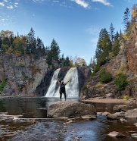

I can’t say enough good things about this property. There is most definitely a reason for all of the previous great reviews! The atmosphere of the studio, as well as the whole farm, is so pleasant and inviting. You can tell that cleanliness and hospitality are top priorities here, and we greatly appreciated all of the little details! I just wish our stay was longer so we could enjoy it more! We will definitely be back when we’re in the area again!

Jacqueline
- October 2022

Just as previous stays here, very clean, comfortable, well stocked, with the benefit of a truly beautiful location. Private, quiet, country studio... just the best! Ericka and Jack are always warm and welcoming. Truly the most lovely airbnb ever, a stay that you will truly love.

Sally
- October 2022

We enjoyed a lovely fall overnight stay at Ericka’s place. The farm is delightful, with chickens, prairie flowers and lots of great wildlife habitat. Our room was very comfortable, and had everything we needed for a pleasant stay. I highly recommend going to the Darwin S. Myers WMA (half mile away) which has trails crossing the Embarrass River.

Michelle
- October 2022

Early Frost Farms airbnb is truly a gem! The studio is more spacious and even more beautiful than the pictures. The space is so cozy and peaceful, and the farm setting is a nice retreat away from towns. Everything we could have asked for, and then some! Erika is also a wonderful host, and the location along the Mesabi trail can't be beat.

Beth
- September 2022

Loved the rural farm setting. Very comfortable and well equipped cottage with super friendly helpful hosts. Wished we could have stayed longer. Highly recommended!

Carole
- September 2022

Great place with charming hosts and beautiful location. Full kitchen with everything you found need. Comfy bed too !

Melissa
- September 2022

Nice, spacious studio on beautiful farm! Ericka & Jack are great people! Not too far from sites around. Very clean!

Jacqueline
- September 2022

A tome could be written on the detailed thoughtfulness of Ericka as a host and how she put together a living space for people to stay. The perfect cotton sheets, the aroma of something like rose pedals perhaps, thoughtful kitchen tools, plush towels, the view of the meadow with the sound of wind going through the surrounding forest. Absolutely the cleanest airbnb I have ever stayed at. Just a dream spot to stay, and the kindest and most interesting hosts you may ever encounter.

Johanna
- September 2022

Very quiet and relaxing. Ideal for anyone with some physical limitations—walk-in shower, no steps, close parking.

Alan
- August 2022

Nice clean place. Quiet.

Dennis
- August 2022

Wonderful stay,lovely place. Hard to beat.

Wally
- August 2022

Hi Ericka
We had a GREAT time at your place. You have a wonderfully peaceful and restful location. The suite was very well stocked with all things we needed or wanted. It was clean and airy.
Our hope is that with the newly paved Mesabi path now running right past your farm, more people will stop by and enjoy your hospitality.

Sara
- August 2022

What a beautiful, quiet, peaceful spot to spend a few days relaxing. Ericka took care of every detail. Perfect base for hiking or going to Ely for the day to shop or see Museums, Bear or a Wolf Center.

Mary
- August 2022

Ericka is a warm and welcoming. A very sweet, restful and mellow spot. Very clean and all the amenities you need!

Gerard
- August 2022

Very quiet clean and relaxing place. Hosts are very welcoming and eager to help. Enjoyed it very much.

Amanda
- August 2022

This space is the perfect peaceful getaway! They provided extra amenities just in case something didnt make it with you. If you're looking for a quiet area with a gorgeous view, kind people, and playful hummingbirds to witness with your morning coffee, this is your spot!

Marley
- August 2022

Erickas place was absolutely perfect for us! The kitchenette had everything we needed to cook a few meals. The view from our windows made you feel like you were all alone on the prairie. Ericka and her husband were extremely hospitable! We had access to their bikes to take advantage of nearby trails. Exceptional value! Highly recommend!!!

Emily
- August 2022

Just an oasis of hospitality, generosity , peace and calm. The studio is perfect. Ericka and Jack are tremendous. We loved birdwatching on the farm, shopping the general store, feeding the chickens and star gazing by firelight. Hard to believe it was all real.

Allen
- July 2022

What a beautiful property, and a lovely, clean cottage. We wish we could have stayed longer! Easy communication and check-in. Chickens!

Baard
- July 2022

Very nice. Very clean. A wonderful setting in northern MN!

Anne
- July 2022

Private entrance to a nice space that has it all! The kitchen is well-equipped. Everything is super clean, quiet, and comfortable. I would definitely stay here again!

Beth
- July 2022

We love this place so much! The sky, the trees and the perfect spot to spend time walking, reading and relaxing. We loved the nearby Finnish historic sites, the paths at Heritage Park, the birds and the berries and just the farm itself. We must recommend the farm stand with fresh eggs, homemade ice cream treats and jams and salsas.

Ellen
- July 2022

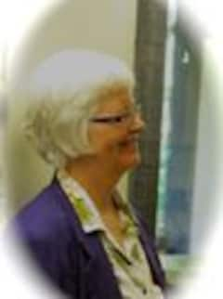

Lovely, quiet place. The middle of July, it was ... hot! But we enjoyed hiking, played some Yahtzee in the shade of the trees. Would love to go again in May or October (shoulder seasons in northern Minnesota).

Robert
- July 2022

What a cute, quiet and so comfortable place to stay. Had everything we needed, good water pressure, plenty of hot water and such a comfortable bed.
It was such a pleasure meeting Ericka and her husband and Noah. We had a very pleasant conversation about travel and AirBnB's. It was just so quiet. You will not be sorry you book here.

Ashley
- July 2022

A beautiful, clean and peaceful place.

Bruce
- July 2022

The Early Frost Farm is a great place to unwind in a peaceful location. There are various things to do in all directions from The Farm. The biking trail that runs right past the farm, will be completed soon. There are also a lot of places to fish nearby. A person can easily spend a day in Ely, as Ely has lots of eateries, a couple brew pubs and several shops.

Bruce
- July 2022

You and Jack were gracious hosts. You gave me good area information and advice. There are more options in your area than I realized. I will certainly recommend Early Frost Farm for a relaxing stay in the north woods. ⭐️⭐️⭐️⭐️⭐️

Snehith
- July 2022

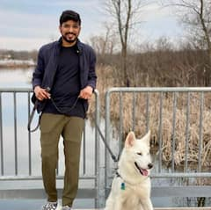

Had a great stay. It was really clean and everything was perfect.

Maria
- June 2022

If you love a quiet, clean, comfortable, & scenic place away from the rush of city life, this is the perfect get-away.
Our room was adorable & the field of pollinators was incredible. Both morning & night we spent on our private patio watching the hummingbirds play.
The Mesabi Trail is literally at the end of their driveway, not to mention the iconic longest floating bridge, in MN.
Highly recommend this place. Owners are wonderful.
Don’t forget to feed the chickens!!

Rebecca
- June 2022

Super cute place. Super clean.

Amalia
- June 2022

Not only was this place charming, quiet, and practical- it was also super comfortable. Ericka made sure the studio was stocked with everything we could possibly need. This was probably one of the most comfortable places I've ever stayed, and for my first trip traveling with a baby it was perfect!

Savannah
- June 2022

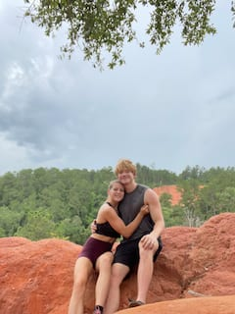

The hosts know a lot about the area. They make sure you have a good time while still respecting your privacy.

Joe
- June 2022

What a great private getaway. Jack and Ericka are terrific hosts and the studio is very well done. 100% recommendation and we’ll be back!

Jill
- June 2022

If you are looking for a comfortable, quiet place, you will not be disappointed. The studio is stocked with all the essentials and many small extras. Erika and Jack are wonderful hosts, they made us feel very comfortable.

Lakshmi
- May 2022

The studio was amazing, very neat with a beautiful view outside

Angela
- May 2022

Very clever studio space with a great location, great view, great amenities, and run by great people. I would stay here again!

Emily
- April 2022

Very nice and clean place to stay while doing clinicals for school!

Beth
- March 2022

Early Frost Farm is a magical place. The studio itself looks out onto open field bordered by spruce bog and a starry sky. The space has everything guests could possibly need to cook, relax, and stay sheltered from big weather, and it is beautifully-appointed. The wee General Store is a great source of homemade chutneys and jams and newly-laid eggs. The hosts' passion for this place is clear, and catching!

Lori
- March 2022

Gorgeous farm that is perfectly situated between Ely, Giants Ridge, and Biwabik.

Jonathan
- March 2022

This is a lovely little getaway I would recommend without hesitation. The space is cute and thoughtfully put together, communication was superb.

Veronica
- March 2022

Lovely location and perfect accommodations for our trip! Ericka was so friendly and great with coordinating. Will definitely be here again for more skiing races and adventures!

Michael
- February 2022

Great place to stay! Very cozy!

Tyler
- February 2022

This place may be tiny but it had a lot to offer and many of the amenities were above and beyond what we expected. The place and owner were very welcoming and just what we were looking for on our trip to Giants Ridge. I would highly recommend this place

Elizabeth
- February 2022 Nice, cozy place to stay.

Beth
- February 2022

A gorgeous modern suite, perfect craftsmanship, field and forest views on a sustainability oriented farm in a unique, historic part of northern Minnesota. Enjoy well tended trails, stunning views and a tiny, cute farm shop with treats and homemade preserves. Plus, charming hosts, a red barn out of a postcard and quiet solitude all around. Wonderful dog, handsome cat are live at the main house. An amazing place that will inspire you!

Josh
- February 2022

This apartment was perfect for our ski getaway! The place is sparkling clean and had all the extras we look for in a good Airbnb, a well stocked kitchen and bathroom. The infloor heating made this apartment very cozy and comfortable, even with the negative temps outside. Definitely check out the little store, the perfect place to buy farm fresh eggs and a few goodies to take home. We would highly recommend this place and would definitely stay again.

Jeanne
- February 2022

So welcoming! Definately recommend this cozy country abode! The hosts are wonderful.

Willem
- February 2022

We loved Ericka’s cozy and well designed space. The pictures don’t lie. Ericka is an awesome host and it was fun to learn about the weather station in her yard. We were up for the State Alpine tournament at Giant’s Ridge. I was so pleased to find this little gem so close to the slopes. Highly recommended!

Addie
- February 2022

Perfect spot to stay if lookin ski at Giants Ridge and explore the Iron Range.

Jeanne
- February 2022

Lovely and welcoming. Definately recommend.

Kylie
- January 2022

Awesome little place to stay! Very quiet and peaceful. Gorgeous property, we stayed for a few days in the winter and were able to snowshoe around the property. We also rented snowmobiles in Babit which was fun. We also got to ski at Giants Ridge which was out favorite part of the trip!

Elise
- January 2022

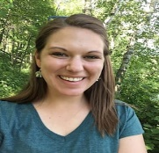

An amazing place to stay! Everything is so modern with a very comfortable bed, fully stocked kitchen and small touches like body wash and a first aid kit. The location is convenient and close to skiing in the area. We hope to visit again soon for a great getaway!

Monika
- January 2022

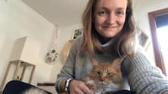

I cannot say enough wonderful things about Ericka and her Airbnb! We spent a long weekend at Early Frost Farms and could not have asked for a better place to stay for our ski weekend! The space was warm, cozy, and comfortable. The kitchen was well stocked and had everything we needed for meals. Ericka and her husband Jack were welcoming from the beginning and recommended some great XC ski spots for us. I would highly recommend staying with them!

Alex
- January 2022

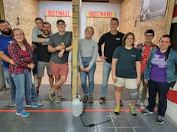

The space provided and cleaniness was fantastic. It was the perfect winter get away for the weekend. Ericka was a terrific host and really made the experience great and easy. The general store is a must visit.

Amy
- December 2021

Ericka’s place is very cozy and clean. Great communication and kitchen is well stocked.

Thuong
- December 2021

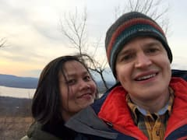

A great quiet and beautiful place to stay on a small Northern Minnesota farm in the woods.

Pauli
- December 2021

We had a lovely stay in the quiet, northern woods! This studio is cozy, modern, and warm in the MN winter. The little details and amenities are fantastic and the bed is very comfy. Highly recommend!

Seth
- December 2021

Awesome place! Such a lovely spot and truly one of the best Airbnb hosts I’ve ever met. Clearly an active part of the community, Ericka and Jack gave us so many good recommendations. The studio was extremely cozy despite the frigid temps. I would recommend this stay to anybody!

Michael
- November 2021

Spanking new place, super friendly hosts, the stars will enchant you, so much charm to be found at Early Frost Farms!

Brenda
- November 2021

Lovely place to stay. Clean and comfortable in a peaceful setting. Very nice kitchen with everything you need and more. Thank you Ericka and Jack. I appreciate your kind hospitality. Definitely would recommend staying here.

Patrick
- October 2021

great little spot for nature lovers

Jenna
- October 2021

Ericka and Jack were such great hosts! We really enjoyed our stay-the location was close to the Iron Range Off road park and yet tucked away in the country for peace and beauty. Jack was very helpful and generous letting us use the garage to tweak the truck before hitting the trails, and Ericka was responsive and kind and also has great grape jelly and eggs! Their property is gorgeous. We will definitely be back.

Bonnie
- October 2021

Great accommodation, comfortable, very quiet, clean. Within 30 minutes of Prospector Trailheads of interest to us. Great, personable hosts. Will definitely book again.

Kurt
- October 2021

Fully decked out kitchen is all I need to say haha. I wasn't expecting and was so surprised and overjoyed with it. The room is separate from the house so lots of privacy the little patio thats out front was nice and relaxing while drinking coffee and enjoying the beautiful fall colors

Caileigh
- October 2021

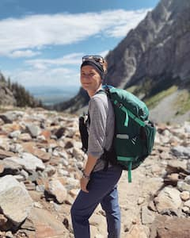

Such a beautiful piece of property! Ericka and her husband we so welcoming and kind. We felt right at home in the cozy guest suite! We would definitely stay here again! Highly recommend!

Cindy
- October 2021

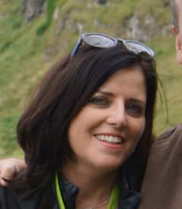

If you are lucky enough to get to stay here you will find two fantastic hosts, a clean, comfortable and beautiful place with a view of a bee and butterfly garden, a little store with delicious items on a working farm - totally exceeded my expectations.

J Joseph
- September 2021

A clean, quite, beautiful getaway!

Kathryn
- September 2021

A great place to stay for a quick getaway!

Austin
- September 2021

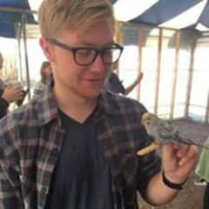

This place was incredibly clean and welcoming. I only had time to spend one night up there but certainly plan on coming back and would recommend anyone going up north in Minnesota stay here and take it all in!

Logan
- September 2021

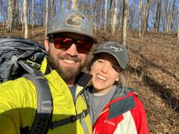

Great stay, everything we needed. Quiet piece of property with great views and a cute little general store with some essentials.

Melissa
- September 2021

Great location! Very quiet, friendly hosts! Trails to walk and general store to shop on farm. Very easy to find and beautiful views! Not too far from North Shore sites!

Tyler
- August 2021

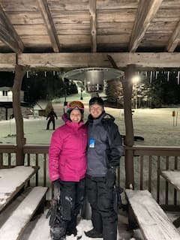

Wonderful hostess, very helpful. Clean and very nice room with a great view of the farm!

Alison
- August 2021

Such a charming stay! We will be coming back :)) Hands down, will recommend to any friends traveling to Ely.

Andrew
- August 2021

Erika did a great job communicating and was very easy to work with. I didn’t arrive until late (1130pm) and the lights were on and everything was ready. Although I didn’t get to meet Erika, as I only spent 1 night and left early the next morning. I would love to come back and see the whole farm!

Cindy
- August 2021

Such a cute place! Highly recommend.

Kahina
- August 2021

Awesome place! has everything you need for a getaway. the kitchen is well furnished if you like to cook your own meals. You can also get fresh produce from the farm from the general store. They had eggs, honey, kale, chard, carrots and even pie! The owners and their neighbor made us feel welcome and at home!

Amy
- August 2021

Ericka and Jack's studio is a rare find Up North on a beautiful farm. The studio is tucked behind their garage overlooking a beautiful field offering privacy and also a feeling of being at home. The hosts were very welcoming, offering tours of their property, and even a shared dinner after a long day exploring Lake Superior. I would suggest grabbing any essential groceries on your way in as the nearest stores are about 20minutes away. The studio has all the amenities and hosts are very responsive if anything is needed. I would recommend trying some of the homemade pies at the general store and giving yourself some time to walk around the property. Grateful I was lucky to come across this little gem.

Vikki
- August 2021

I've stayed in many Airbnb's and this is one of the absolute best! The suite is brand new and filled to the brim with amenities and extras! Ericka has thought of everything down to the first aid kit in the bathroom! We stayed after 6 days in BWCA and felt like we extended our nature time with the beautiful country setting. The bed and pull out couch were very comfortable, and the full equiped kitchen and BBQ were such a treat allowing us to make a wonderful dinner! Do yourself a favor and stay at this spot, buy a fresh baked pie and and locally laid eggs in their general store. Ericka and Jack represent the best of MN nice. Wish we would have had more time here. Strong recommend!!

Miriam
- August 2021

Wonderful little escape! This studio is well-appointed, impeccably clean and sparkling! We arrived for our overnight stay late in the evening and walked into a personalized note greeting us, fresh smell and comfy accommodations. The general store had fresh eggs and kale for sale in addition to treats, and Ericka is a delight. We spent our day exploring the Ancient Cedar Trail in Tower, then touring Ely. Very easy drives! This is a great place to stay!

Vanessa
- August 2021

Perfect, serene, off the beaten path. The guesthouse was clean and comfy.

Stacy
- August 2021

Super host! Friendly and great communication! Beautiful location! Highly recommended!

Anne
- July 2021

I am a frequent Airbnb user on my travels, and I can honestly say that your place is the nicest Airbnb I've ever stayed at. Everything is spic and span and the amenities are SO GOOD!!! Would stay here again!

Eric
- July 2021

Gorgeous location. Unique in so many ways. Well worth the stop. I would've loved a bit more time to explore the area. Stay safe and be well.

Michelle
- July 2021

My girlfriend and I stayed with Ericka and Jack over the weekend of the Blueberry Festival in Ely. The festival was unexpectedly cancelled due to a massive storm, but we weren't disappointed at all because it gave us more time on their beautiful farm! We almost don't want to tell you how amazing this place was because we want to keep it all to ourselves... This is hands down the BEST Airbnb either of us has ever stayed at. It's the perfect escape from the cities. They are the most wonderful, accommodating hosts in the world. Their studio is so cute with a *gorgeous* sunset view. But the highlight for us was definitely their sweet dogs. They let us borrow them on our walks! Do yourselves a favor and book a stay with them today. I promise you won't regret it. We loved them so much that we're already planning three more trips to Embarrass! Can't wait! ❤️

Ellen
- July 2021

Wonderful place you can truly relax at. Super quiet area in the North Country. ❤️❤️❤️

Veda
- June 2021

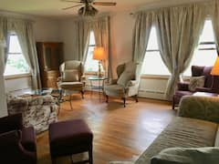

This is a charming, well maintained and very clean little house in a tranquil place. Highly recommend.

Lateja
- June 2021

Literally one of the nicest people I’ve met! I recommend stay here if you want a nice and relaxing time away from the city.

Ted
- June 2021

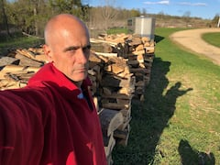

My wife and I enjoyed every aspect of the visit. We were looking for a quiet place, off the beaten path, as we visited northern MN. This place is perfect. The view overlooking the hayfield/meadow was idyllic. The quiet was appreciated. We had a very pleasant conversation with our host and hostess, which was above and beyond what was needed. The accommodations were spotless and there certainly would have been the ability to make a very nice meal, if we’d wanted to go that route. Highly recommended for those looking for a bit of off the beaten path quiet time.

Melrine C
- June 2021

Treat yourself, Ericka absolutely spoiled me!

Abby
- June 2021

Spectacular hosts! 10/10 recommend staying here. They were available for any need and had excellent communication. I even got a homemade sticky bun from them - yum!!

Tim
- June 2021

Thank you to Ericka for the great communication. We understand that the cancelation due to the forest fire and evacuation was not your fault. Thanks for being so gracious as to call to make sure we found other accommodations. We look forward to staying with you on our next trip to the area.

